1. Write a Python program to print the following string in a specific format

(see the output).

Twinkle, twinkle, little star,

How I wonder what you are!

Up above the world so high,

Like a diamond in the sky.

Twinkle, twinkle, little star,

How I wonder what you are

CODE:  
poem = "Twinkle, twinkle, little star, \n\t How I wonder what you are! \n\t\t Up above the world so high, \n\t\t Like a diamond in the sky. \n Twinkle, twinkle, little star, \n\t How I wonder what you are"

print(poem)

OUT PUT:

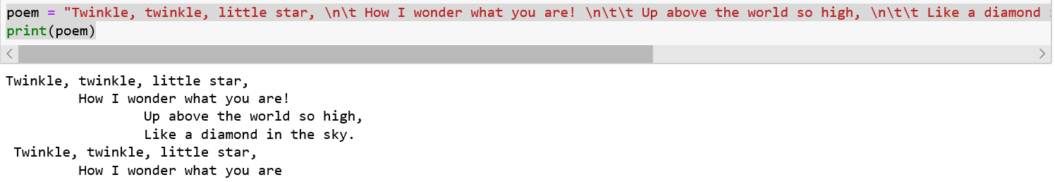

2. Write a Python program to get the Python version you are using.

CODE:

import sys

print("python version")

print(sys.version)

print("python version")

print(sys.version_info)

OUTPUT:  
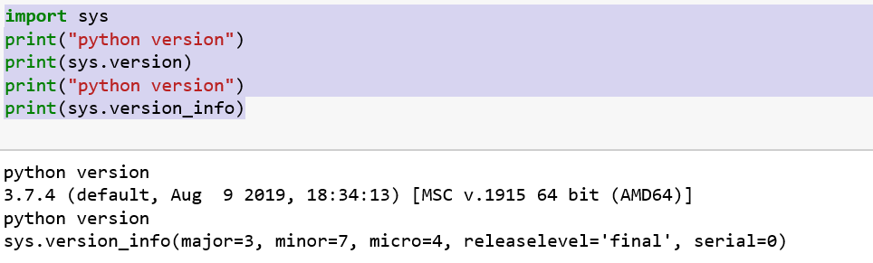

3. Write a Python program to display the current date and time.

CODE:

from datetime import datetime

now = datetime.now()

print("current date & current time")

print(now)

OUTPUT:

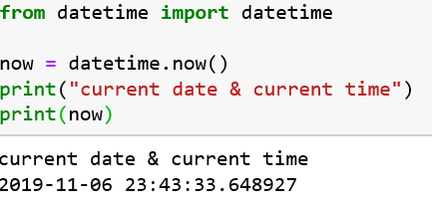

4. Write a Python program which accepts the radius of a circle from the user

and compute the area.

CODE:

r =(int(input("enter a radius")))

pi = 3.14

a = pi*(r**2)

print("area of a circle is " + str(a))

OUTPUT:

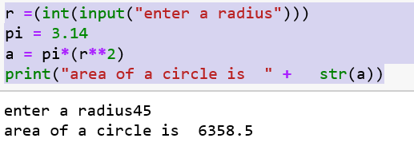

5. Write a Python program which accepts the user's first and last name and

print them in reverse order with a space between them.

CODE:

first_name =input("enter your first name")

last_name =input("enter your last name")

print("first name" + first_name)

print("last name" + last_name)

print(last_name +" "+first_name)

OUTPUT:

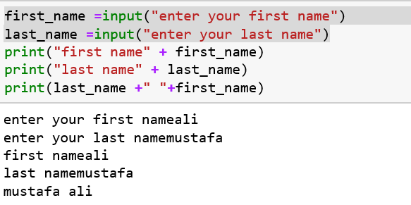

6. Write a python program which takes two inputs from user and print them

Addition

CODE:

n1 =(int(input("enter a first num ")))

n2 =(int(input("enter a second num ")))

n3 = n1 + n2

print (n3)

OUTPUT:

